Hive supports all applications written in languages like C++, JAVA, Python etc, using JDBC, Thirft and ODBC drivers.
Below diagram depicts HIVE architecture

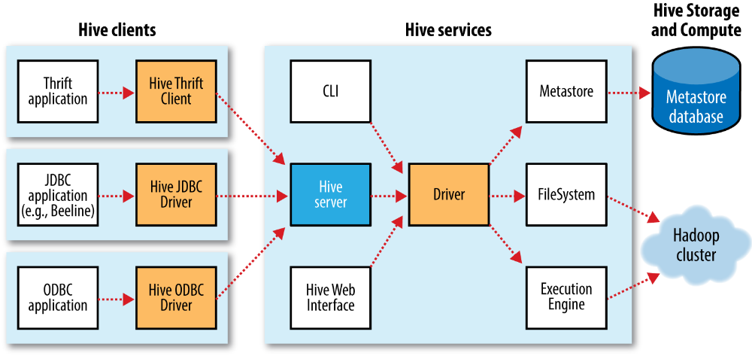

So basically its architecture has below core components which run on top of Hadoop cluster-
- HIVE CLIENTS- The Hive supports different types of client applications for performing queries. These clients are categorized into 3 types:
- Thrift Client- Apache HIVE SERVER is based on Thrift, so it is possible to serve the request from all those languages that support Thrift.
- JDBC Clients- Hive provides a Type 4 (pure Java) JDBC driver, defined in the class org.apache.hadoop.hive.jdbc.HiveDriver. When configured with a JDBC URI
of the form jdbc:hive2://host:port/dbname, a Java application will connect to a
Hive server running in a separate process at the given host and port. (The driver
makes calls to an interface implemented by the Hive Thrift Client using the Java
Thrift bindings.)
- ODBC Clients- ODBC Driver allows applications that support ODBC protocol to connect to Hive. For example JDBC driver, ODBC uses Thrift to communicate with the Hive server.
- HIVE SERVICES- Below are the HIVE Services shown in the above diagram-
- cli- This is the default service shell where we can run our commands and queries directly.
- Hiverserver2- It runs Hive as a server exposing a Thrift service, enabling access from a range of clients written in different languages. HiveServer 2 improves on the original Hive‐Server by supporting authentication and multiuser concurrency. Applications using the Thrift, JDBC, and ODBC connectors need to run a Hive server to communicate with Hive.
- Beeline- A command-line interface to Hive that works in embedded mode (like the regular
CLI), or by connecting to a HiveServer 2 process using JDBC.
- hwi- The Hive Web Interface. A simple web interface that can be used as an alternative
to the CLI without having to install any client software.
- Jar- The Hive equivalent of hadoop jar, a convenient way to run Java applications that
includes both Hadoop and Hive classes on the classpath.
- Metastore- By default, the metastore is run in the same process as the Hive service. Using this service, it is possible to run the metastore as a standalone (remote) process. It is the central repository of Apache Hive metadata in the Hive Architecture. It stores metadata for Hive tables (like their schema and location) and partitions in a relational database. It provides client access to this information by using metastore service API.
Hive metastore consists of two fundamental units:
    - A service that provides metastore access to other Apache Hive services.
    - Disk storage for the Hive metadata which is separate from HDFS storage.
By default it is DERBY database. It is also known as embedded metastore configuration. However, only one embedded Derby database can access the database files on disk at any one time, which means we can have only one Hive session open at a time that accesses the same metastore. Trying to start a second session produces an error when it attempts to open a connection to the metastore.

All configurations of metastore is shown in below diagram-

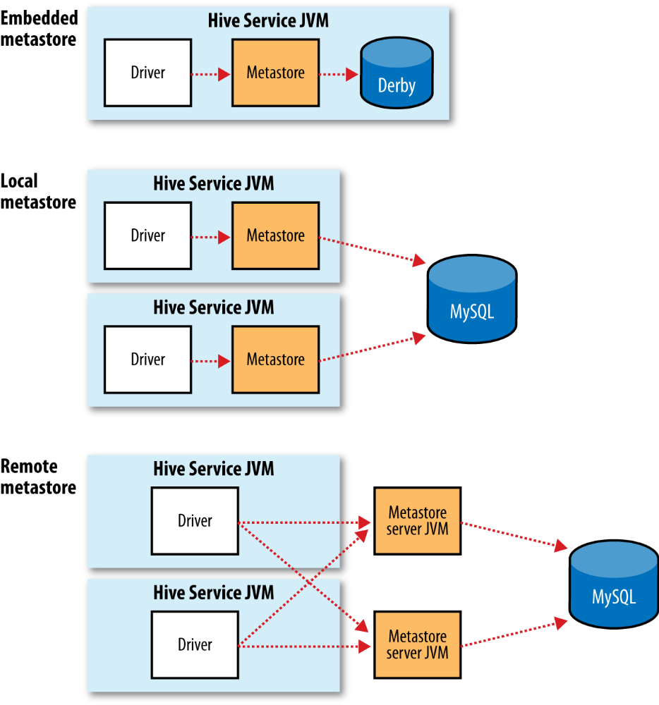
The solution to supporting multiple sessions (and therefore multiple users) is to use a standalone database. This configuration is referred to as a local metastore, since the metastore service still runs in the same process as the Hive service but connects to a database running in a separate process, either on the same machine or on a remote machine. Any JDBC database can be used for the same for ex- MYSQL.
There’s another metastore configuration called a remote metastore, where one or more metastore servers run in separate processes to the Hive service. This brings better manageability and security because the database tier can be completely firewalled off, and the clients no longer need the database credentials.

